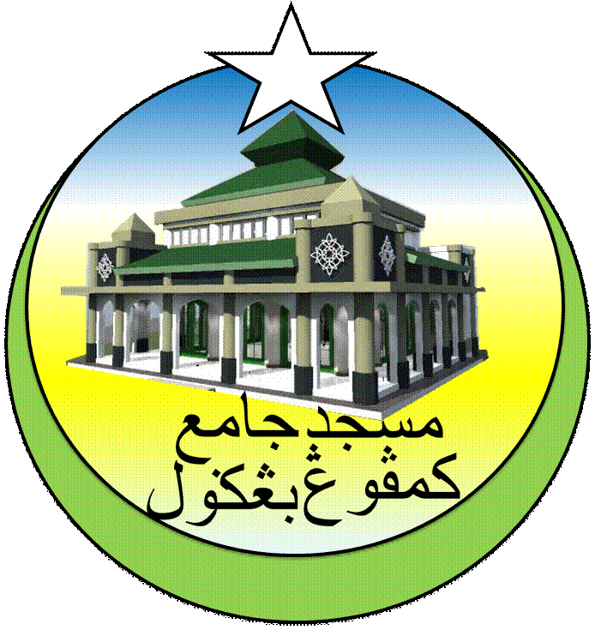**PROGRAM QARYAHKU PRIHATIN**

**MASJID JAMEK KAMPUNG BANGGOL 2018**

**TARIKH: HARI: KAWASAN:**

|  |  |  |  |
| --- | --- | --- | --- |
| **BIL** | **NAMA** | **ALAMAT** | **KAD PENGENALAN** |
| 1 |  |  |  |
| 2 |  |  |  |
| 3 |  |  |  |
| 4 |  |  |  |
| 5 |  |  |  |